Tree Node

The code to write a tree node would be similar to what is given below. It has a data part and references to its left and right child nodes.

| struct node {  int data;  struct node *leftChild;  struct node *rightChild;  }; |
| --- |

In a tree, all nodes share common construct.

Insert Operation

The very first insertion creates the tree. Afterwards, whenever an element is to be inserted, first locate its proper location. Start searching from the root node, then if the data is less than the key value, search for the empty location in the left subtree and insert the data. Otherwise, search for the empty location in the right subtree and insert the data.

Algorithm

| If root is NULL  then create root node  return  If root exists then  compare the data with node.data    while until insertion position is located  If data is greater than node.data  goto right subtree  else  goto left subtree  endwhile    insert data  end If |
| --- |

Implementation

| void insert(int data) {  struct node *tempNode = (struct node*) malloc(sizeof(struct node));  struct node *current;  struct node *parent;  tempNode->data = data;  tempNode->leftChild = NULL; |
| --- |

| tempNode->rightChild = NULL;  //if tree is empty, create root node  if(root == NULL) {  root = tempNode;  } else {  current = root;  parent = NULL;  while(1) {  parent = current;  //go to left of the tree  if(data < parent->data) {  current = current->leftChild;    //insert to the left  if(current == NULL) {  parent->leftChild = tempNode;  return;  }  }  //go to right of the tree  else {  current = current->rightChild;    //insert to the right  if(current == NULL) {  parent->rightChild = tempNode;  return;  }  }  }  }  } |
| --- |

Search Operation

Whenever an element is to be searched, start searching from the root node, then if the data is less than the key value, search for the element in the left subtree. Otherwise, search for the element in the right subtree. Follow the same algorithm for each node.

Algorithm

| If root.data is equal to search.data  return root  else  while data not found  If data is greater than node.data |
| --- |

| goto right subtree  else  goto left subtree    If data found  return node  endwhile    return data not found    end if |
| --- |

| struct node* search(int data) {  struct node *current = root;  printf("Visiting elements: ");  while(current->data != data) {  if(current != NULL)  printf("%d ",current->data);    //go to left tree  if(current->data > data) {  current = current->leftChild;  }  //else go to right tree  else {  current = current->rightChild;  }  //not found  if(current == NULL) {  return NULL;  }  return current;  }  } |
| --- |

In-order Traversal

In this traversal method, the left subtree is visited first, then the root and later the right sub-tree. We should always remember that every node may represent a subtree itself. If a binary tree is traversed **in-order**, the output will produce sorted key values in an ascending order.

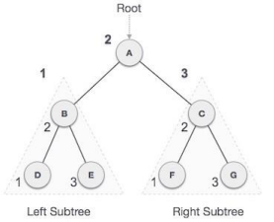

We start from **A**, and following in-order traversal, we move to its left subtree **B**. **B** is also traversed in-order. The process goes on until all the nodes are visited. The output of inorder traversal of this tree will be −

***D → B → E → A → F → C → G***

Algorithm

Until all nodes are traversed −

**Step 1** − Recursively traverse left subtree.

**Step 2** − Visit root node.

**Step 3** − Recursively traverse right subtree.

Pre-order Traversal

In this traversal method, the root node is visited first, then the left subtree and finally the right subtree.

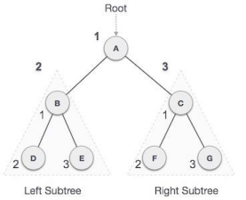

We start from **A**, and following pre-order traversal, we first visit **A** itself and then move to its left subtree **B**. **B** is also traversed pre-order. The process goes on until all the nodes are visited. The output of pre-order traversal of this tree will be −

***A → B → D → E → C → F → G***

Algorithm

Until all nodes are traversed −

**Step 1** − Visit root node.

**Step 2** − Recursively traverse left subtree.

**Step 3** − Recursively traverse right subtree.

Post-order Traversal

In this traversal method, the root node is visited last, hence the name. First we traverse the left subtree, then the right subtree and finally the root node.

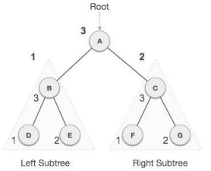

We start from **A**, and following Post-order traversal, we first visit the left subtree **B**. **B** is also traversed post-order. The process goes on until all the nodes are visited. The output of post-order traversal of this tree will be −

***D → E → B → F → G → C → A***

Algorithm

Until all nodes are traversed −

**Step 1** − Recursively traverse left subtree.

**Step 2** − Recursively traverse right subtree.

**Step 3** − Visit root node.